Weight Testing

Phase enhancement definition (may need this)

<https://docs.acconeer.com/en/latest/radar_data_and_control/a121/in_depth_topics/loopback.html#phase-enhancement>

I will be testing different weights looking for noticeable differences trying to settle on a good weight. We will be starting at 6 grams since this is around where we have been testing before.

**NOTE: I am adding a .2 tolerance to the weight meaning the weight can be between 5.8 - 6.2 grams and so on with testing. Also, for this testing, I have turned down the gain to 17 because this is the point at which the sensor is not fully saturated with our settings.**

I am using the same method I did before with the following steps

1. Add Desired amount to tube
2. Screenshot the signal, this is the before image
3. Shake the beans up
4. Screenshot the new image
5. Remove the beans and add 1g to the amount then replace, all the way up to 7 repeating steps 1 - 4 each time.

**India Monsoon Malabar 12.2%**

8 grams (This is where we no longer have a defined peak. This means 7 should be the max to test at)

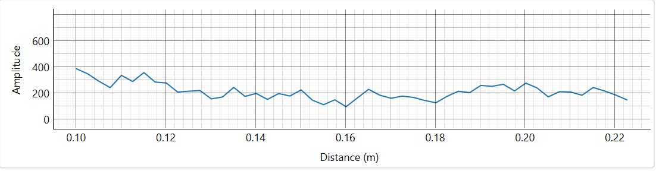

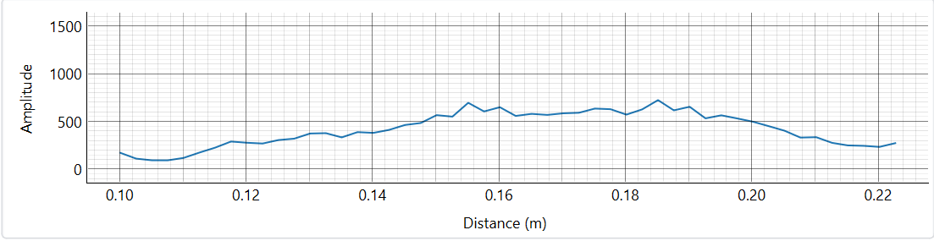7 grams

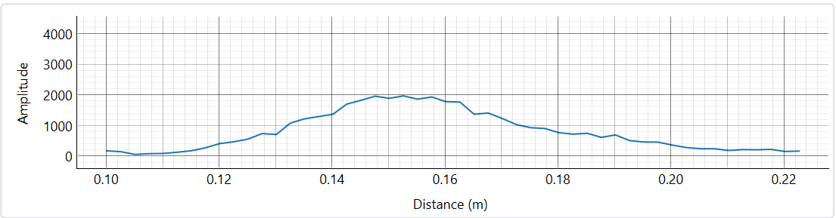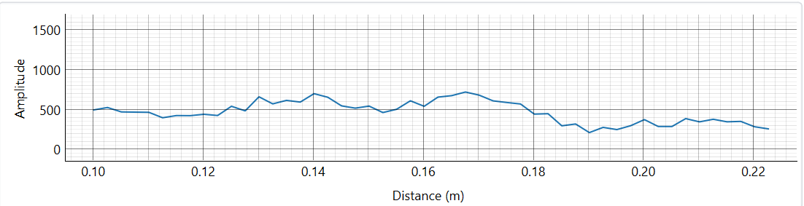

6 grams

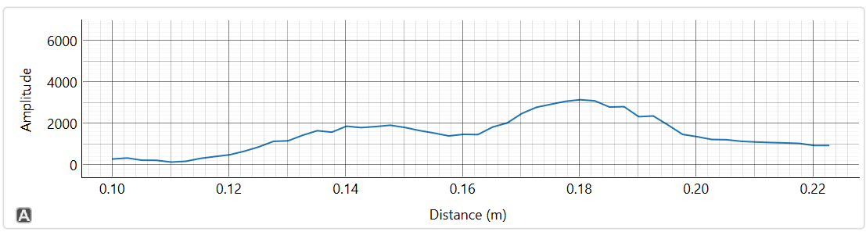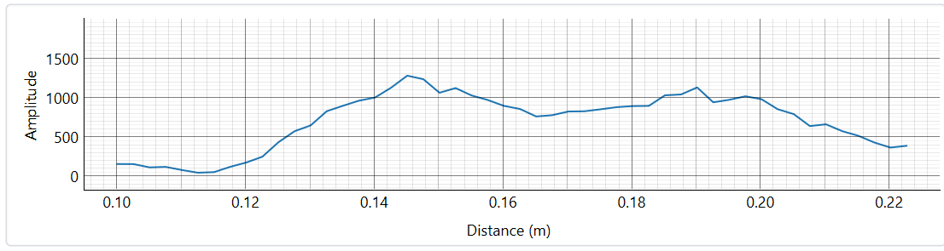

5 grams

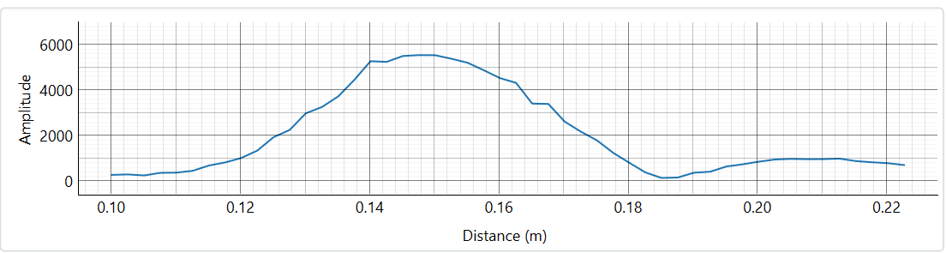

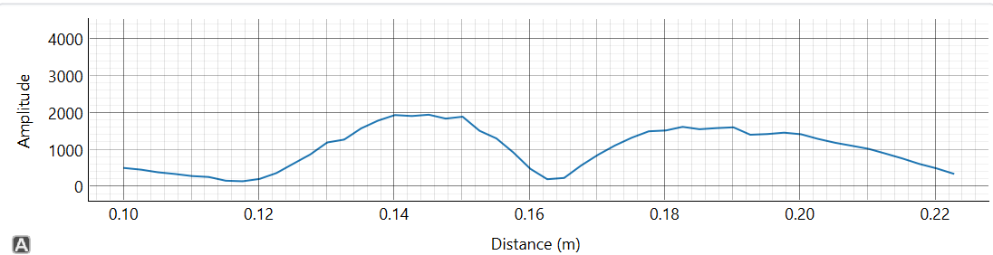4 grams

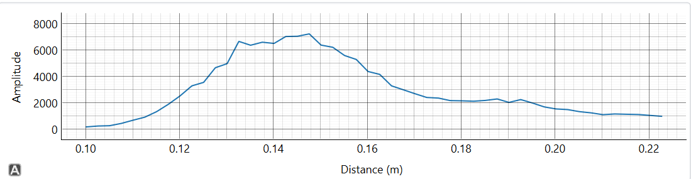

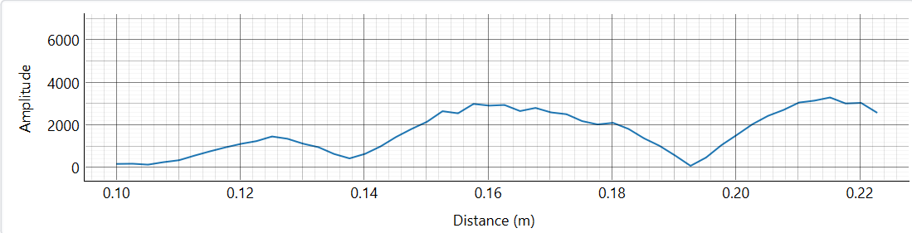

**Yemen Mokha Peaberry 10.4%**

7 grams

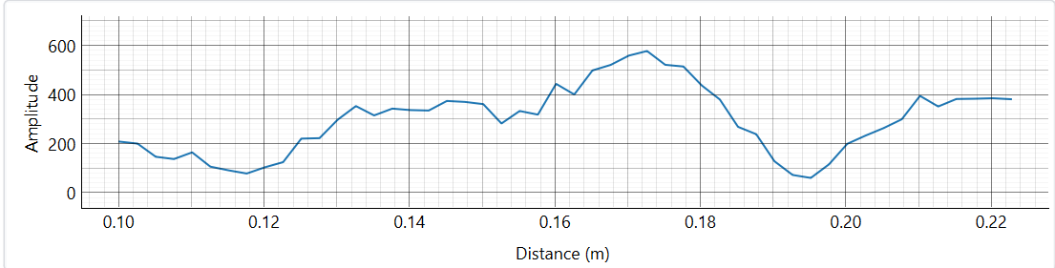

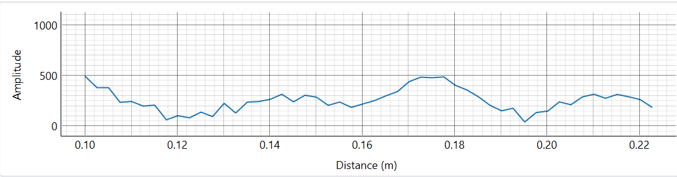6 grams

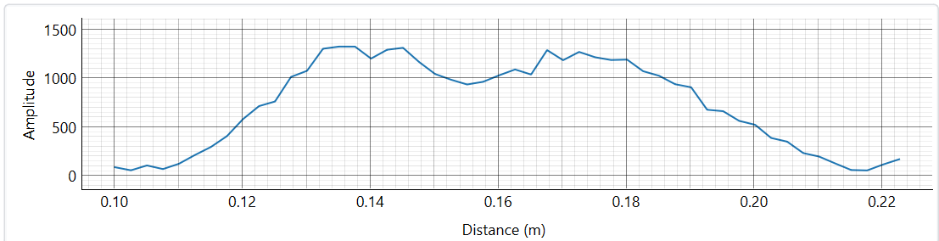

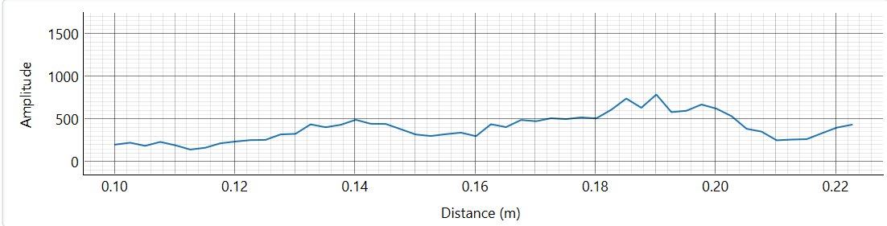5 grams

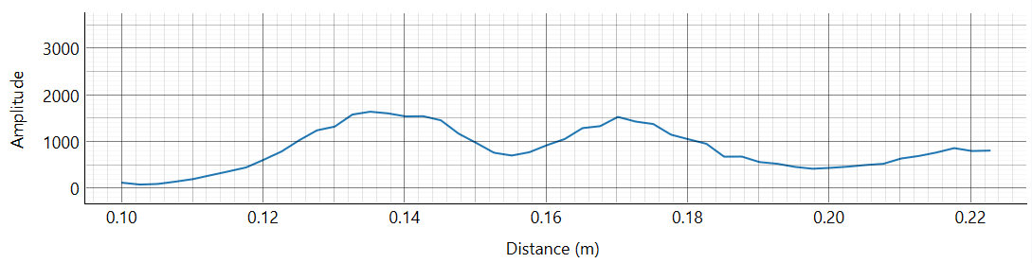

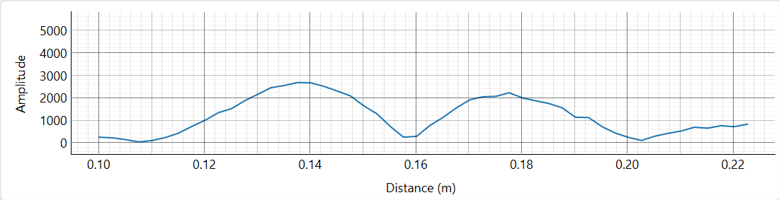4 grams

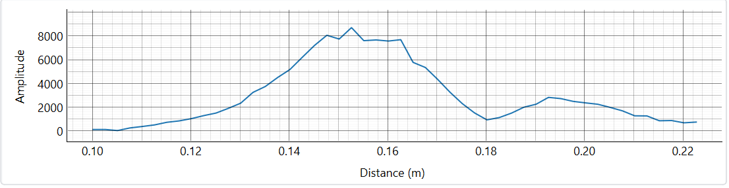

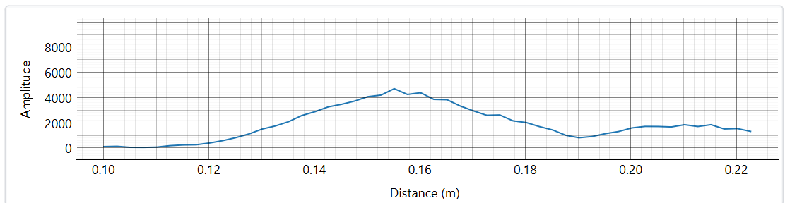

**Guatemala Antigua Hunapu Ciudad Vieja 7.8%**

7 grams

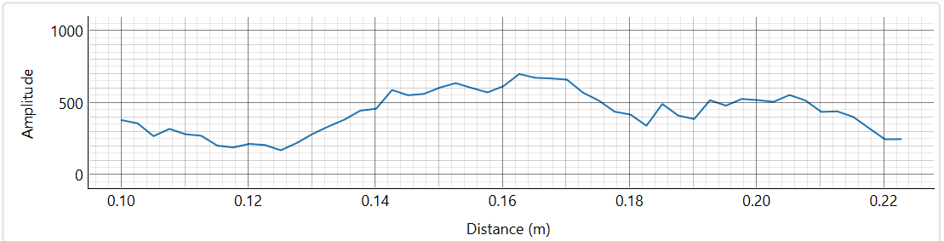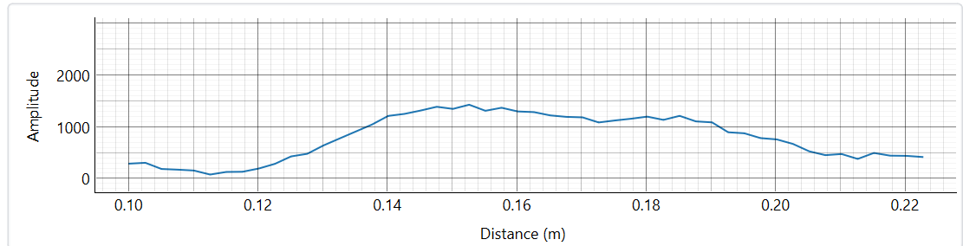

6 grams

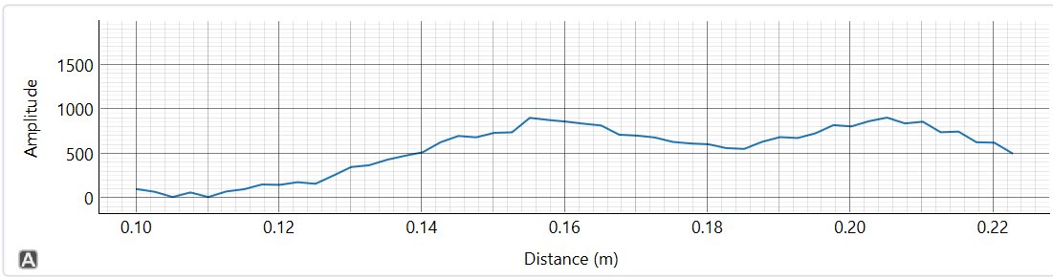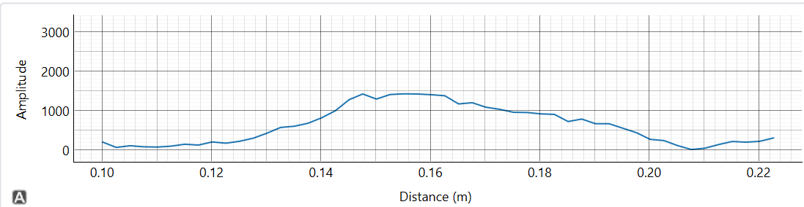

5 grams

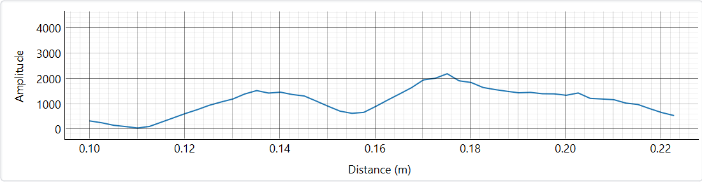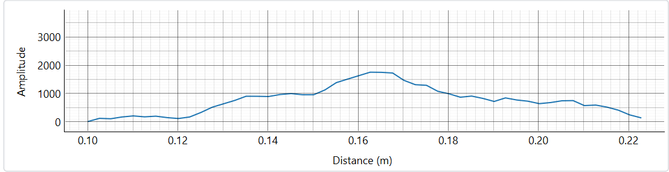

4 grams

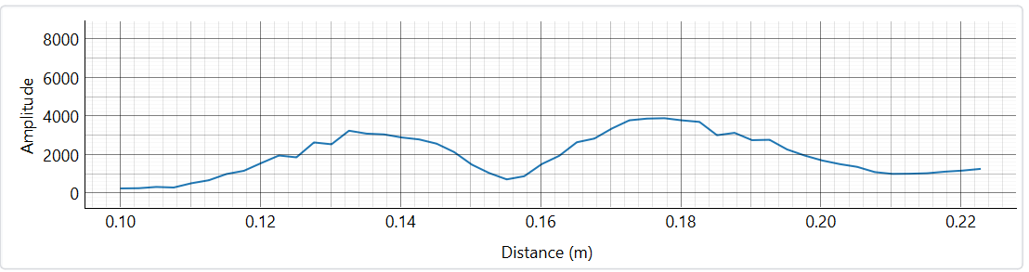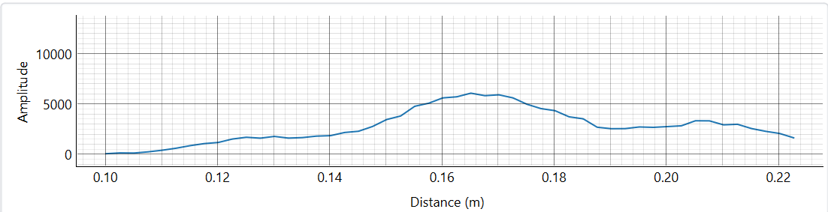

**Yemen Mokha Sanani 11.4%**

7 grams

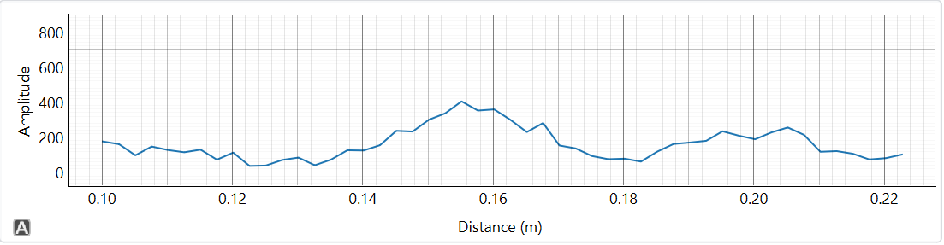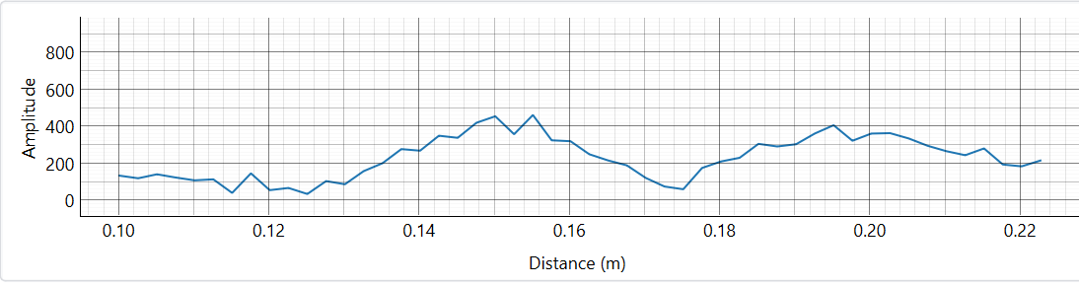

6 grams

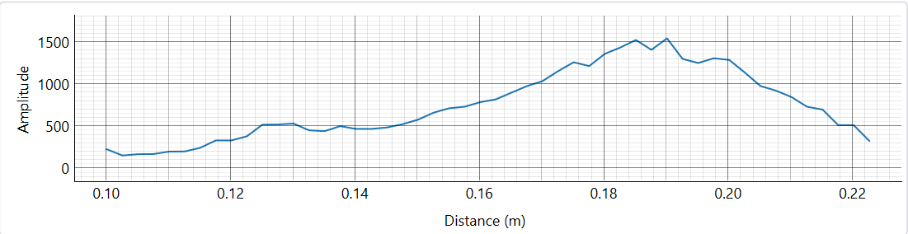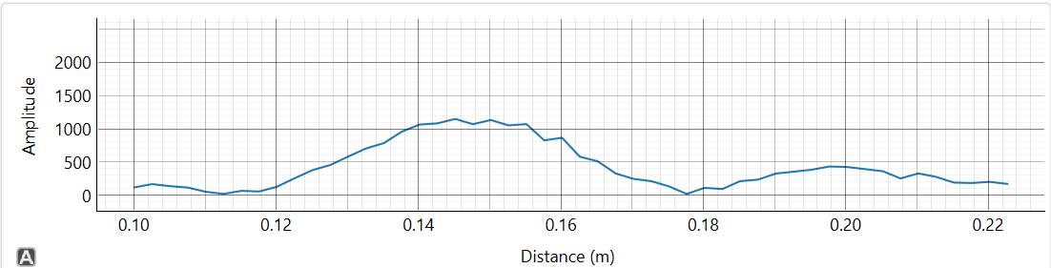

5 grams

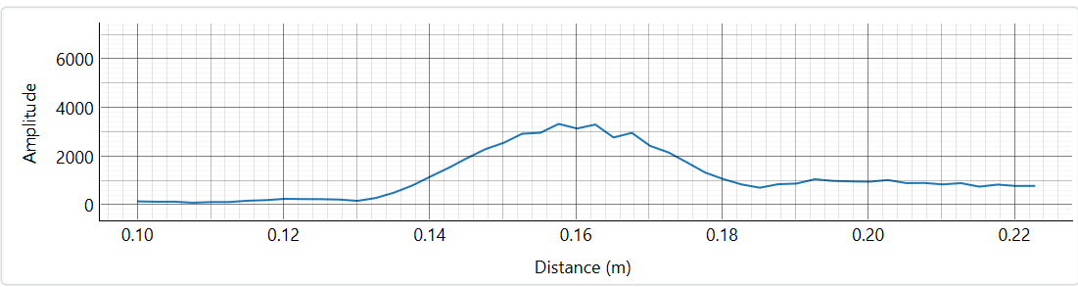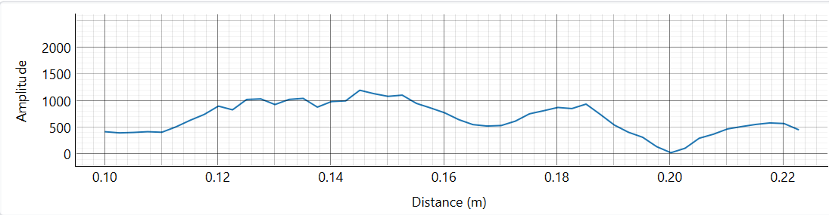

4 grams